*Florida International University*

*School of Computing and Information Sciences*

CIS 4911 - Senior Capstone Project

Software Engineering Focus

Feature Document

User Story #552

**Team Member:**

Andrew Mitchell

**Product Owner(s)**:

Francisco R. Ortega

**Mentor(s)**:

Francisco R. Ortega

...

**Instructor**: Masoud Sadjadi

# 

# **User Story** – Create Circle Shape

* As a User I would like to draw a predefined circle so my circles are smooth.

## **Use Case – Draw Circle Shape**

Use Case

Create a Circle Shape

Details:

Actor: User

Pre-conditions:

Touch screen working.

‘Enable circle mode’ (key ‘i’)

Program Running.

Description:

Use case begins when a user presses a key (i, Temporary until design philosophy is completed). This will alter the touch screen to draw circles instead of lines.The user story ends when the user successfully draws a circle and lets go.

Post-conditions:

Circle’s will be drawn on the touchscreen

Can be filled circles if filled mode is on.

Decision Support:

Frequency: Very High. Drawing smooth circles is highly useful.

Criticality: High. Enables more ways to paint on the canvas.

Risk: Medium. Team member needs to learn to use more libcinder shapes, how to call these draw functions effectively.

Constraints:

Usability:

Just need to learn the proper keybinding.

Reliability: Very Reliable.

Mean time to Failure – Should only fail in extreme conditions. (Keyboard input overloads etc).

Availability – Always available (may change at a future date).

Performance:

Circles should be drawn smoothly when we drag our finger.

Supportability:

Must work with ACER Multitouch.

Modification History:

Owner: Andrew Mitchell

Initiation date: 02/4/2016

Date last modified: 02/14/2016

## **Use Case Diagram**

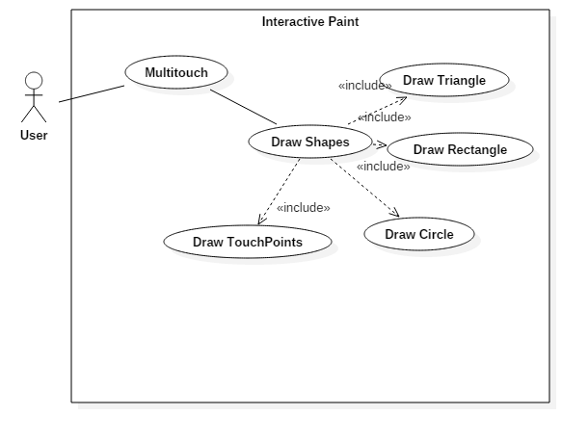

## **Sequence Diagram**

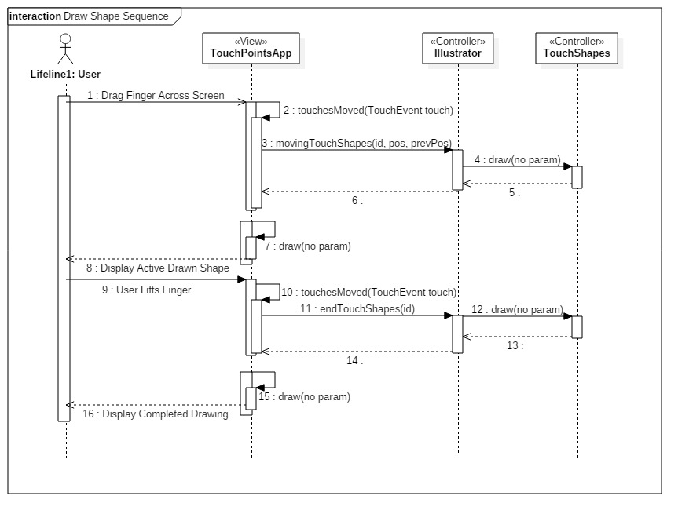

## 

## 

## **Class Diagram**

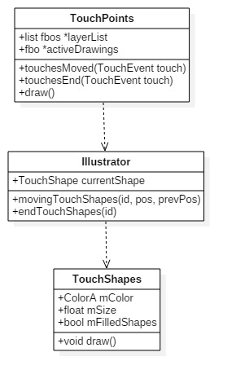

## 

## 

## 

**Unit Test**

Sunny Day:

Test Case: Draw Circle

Test Purpose:

Ensure that drawing a circle is possible.

Test Setup:

1. Press the ‘Shapes Button’
2. Press the Circle Shape
3. Press a finger to the multitouch
4. Drag Finger

Test Output:

Drew a circle shape.

Expected Output:

A black circle should be drawn based on how far you dragged your finger.

Rainy Day Tests:

Test Case: Draw lines after circles

Test Purpose:

Ensure we can change from one shape to another without any hiccups.

Test Setup:

1. Drag finger across multitouch
2. Press ‘Shapes Button’
3. Press ‘Circle’ button
4. Drag finger across multitouch
5. Press shapes button
6. Press Line button
7. Drag finger across multitouch.

Test Output:

Expected Output:

The user should have drawn one line first, then a circle, then another line.

## 

## **Integration Test**

Our circle shape is currently working.

It works with our color changes as well as line size changes to our brush. In addition alpha colors now works.

It has been successfully integrated to work with the Leap Motion, Multitouch, and Real Sense device.

## 

## **User Guide**

Use the shapes button at the top left to select shapes.

Choose the ‘Circle’ shape to draw circles!

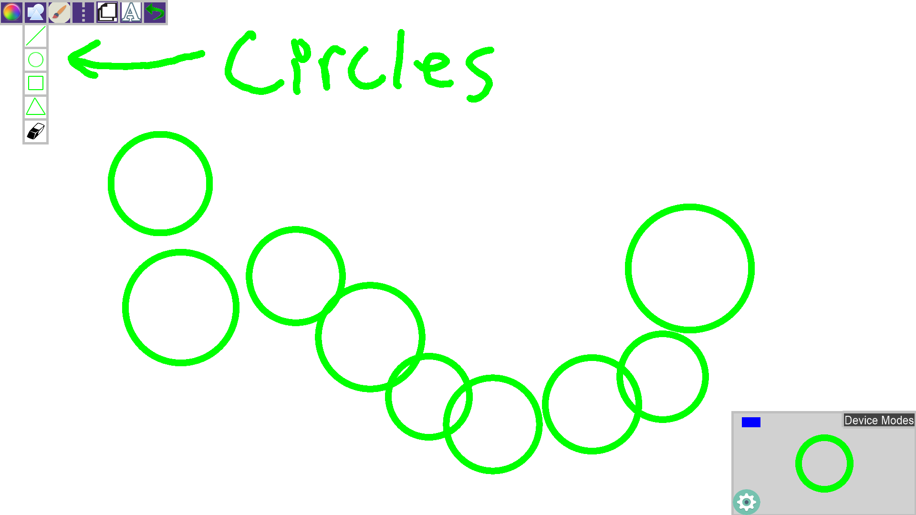

**Glossary**

TouchCircles – Circle shape that can be used by our illustrator.